**CIVICS REVIEW: Separation of Powers**

**Part A: Matching.** As a class, we will read through “The Constitution” PDF. Use this reading as a guide to help you match the correct key words in the word bank to their definitions. You will use each word once.

|  |  |  |  |  |
| --- | --- | --- | --- | --- |
| Bill of Rights | Population | Constitution | Executive | Separation of Powers |
| Amendments | Congress | Senators | Legislative | Representative Democracy |
| President | Bill | Preamble | Judicial | Checks and Balances |

|  |  |
| --- | --- |
| **DEFINITION:** | **KEY TERM:** |
| 1) The two houses that make up the legislative branch. | Congress |
| 2) Citizens elect officials to represent them in the government. |  |
| 3) Dividing the government into three parts. |  |
| 4) When the three branches interact with each other and limit the power of each other. |  |
| 5) The introduction to the US Constitution that states the goals and purposes of government. |  |
| 6) The first 10 amendments to the Constitution. |  |
| 7) A document that gives the rules for how a government should run. |  |
| 8) There are two __________ per state who serve for 6 year terms. |  |
| 9) The number of representatives in the House of Representatives is based on the __________ of a state, or the number of people in it. |  |
| 10) The leader of the executive branch is the ___________. |  |
| 11) A proposed law is called a ___________. |  |
| 12) This branch of government makes the laws. |  |
| 13) This branch of government enforces the laws. |  |
| 14) This branch interprets the laws to decide what they mean. |  |
| 15) Changes made to the Constitution after it was written. |  |

**Part B. Multiple Choice**. Based on our reading and discussion, answer the following questions.

**16) Which part of the U.S. Constitution states the six purposes of government, or what the government is meant to do? [p. 1]**

*A) Bill of Rights*

*B) Article IV*

*C) Preamble*

*D) Article I*

ANSWER: ____

**17) Where can a description of U.S. citizens' civil liberties and rights be found? [p. 1]**

*A) Declaration of Independence*

*B) Preamble to the Constitution*

*C) Pledge of Allegiance*

*D) Bill of Rights*

ANSWER: ____

**18) In the Preamble to the U.S. Constitution, what is the meaning of the phrase "We the People"? [p. 2]**

*A) The people express their will through political parties.*

*B) The people express their will by directly creating laws.*

*C) Government receives taxes from the people and exists to support them.*

*D) Government receives its power from the people and exists to serve them.*

ANSWER: ____

**19) Which branch of government would be responsible for declaring war on another country? [p. 2]**

*A) Legislative Branch*

*B) Executive Branch*

*C) Judicial Branch*

*D) This is not something that the federal government would do.*

ANSWER: ____

**20) Which branch of government negotiates treaties with other countries? [p. 3]**

*A) Legislative Branch*

*B) Executive Branch*

*C) Judicial Branch*

*D) This is not something that the federal government would do.*

ANSWER: ____

**21) Sally is 32 years old and was born in New York. She moved to Japan with her family when she was 4 years old but moved back to the United States when she was 12 and has lived in the United States since then. Can she run for president? [p. 3]**

*A) Yes! She meets all of the requirements.*

*B) No! She is not old enough.*

*C) No! She has not lived in the United States for long enough.*

*D) No! She does not meet the citizenship requirements.*

ANSWER: ____

**22) The passage below is from Federalist No. 47, written by James Madison in 1788.**

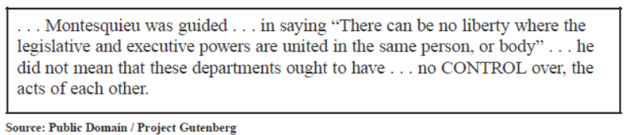

**Based on this passage, which constitutional principle does Madison describe? [p. 4]**

*A) Separation of powers*

*B) Checks and balances*

*C) Popular sovereignty*

*D) Judicial review*

ANSWER: ____

**23) Which of the following is NOT true about the lawmaking process? [p. 4]**

*A) The two branches of Congress create and vote on a bill that they believe should become law.*

*B) After passing Congress, the President must sign or veto a bill.*

*C) The judicial branch can override a presidential veto of a bill.*

*D) It is the job of the judicial branch to review laws and determine if they are unconstitutional.*

ANSWER: ____

**24) All of the following are checks, or limits, that the legislative branch has on the executive branch EXCEPT for: [p. 5]**

*A) Congress can override a presidential veto with a 2/3 vote.*

*B) It can impeach a president for wrongdoings.*

*C) It approves presidential appointments ambassadors and members of the Cabinet.*

*D) It can appoint federal judges.*

ANSWER: ____